- DESIGN A CPU SCHEDULING PROGRAM WITH C USING FIRST COME FIRST SERVED TECHNIQUE
Aim:
To write a C program to schedule processes based on their arrival order using FCFS scheduling.
Program:
#include <stdio.h>
int main()
{
int n, i, bt[20], wt[20], tat[20];
float avgwt = 0, avgtat = 0;
printf("Enter number of processes: ");
scanf("%d", &n);
for (i = 0; i < n; i++)
{
printf("Enter burst time of P%d: ", i + 1);
scanf("%d", &bt[i]);
}
wt[0] = 0;
for (i = 1; i < n; i++)
wt[i] = wt[i - 1] + bt[i - 1];
for (i = 0; i < n; i++)
{
tat[i] = wt[i] + bt[i];
avgwt += wt[i];
avgtat += tat[i];
}
printf("\nProcess\tBT\tWT\tTAT\n");
for (i = 0; i < n; i++)
printf("P%d\t%d\t%d\t%d\n",
i + 1, bt[i], wt[i], tat[i]);
printf("Average Waiting Time: %.2f\n", avgwt / n);
printf("Average Turnaround Time: %.2f\n", avgtat / n);
return 0;
}

Output:
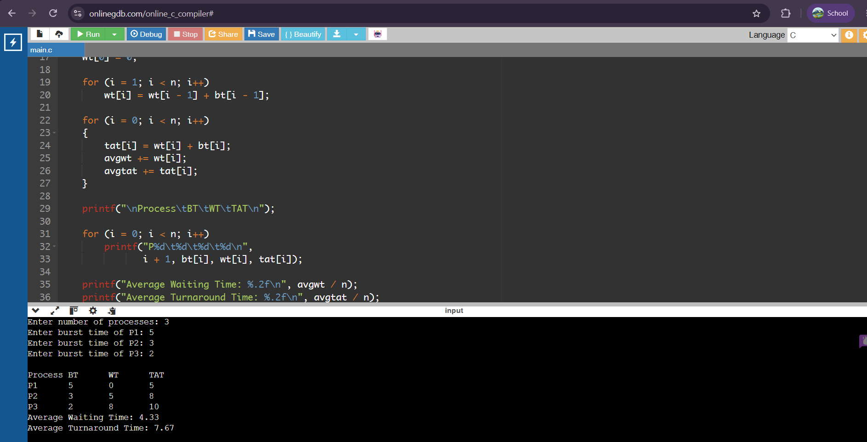

Process BT WT TAT
P1 5 0 5
P2 3 5 8
P3 2 8 10
Average Waiting Time: 4.33
Average Turnaround Time: 7.67

- DESIGN A CPU SCHEDULING PROGRAM WITH C USING SHORTEST JOB FIRST

Aim:
To write a C program that selects the waiting process with the smallest execution time first.
Program:
#include <stdio.h>
int main()
{
int n, i, j, bt[20], wt[20], tat[20], temp;
float avgwt = 0, avgtat = 0;
printf("Enter number of processes: ");
scanf("%d", &n);
for (i = 0; i < n; i++)
{
printf("Enter burst time of P%d: ", i + 1);
scanf("%d", &bt[i]);
}
for (i = 0; i < n - 1; i++)
{
for (j = i + 1; j < n; j++)
{
if (bt[i] > bt[j])
{
temp = bt[i];
bt[i] = bt[j];
bt[j] = temp;
}
}
}
wt[0] = 0;
for (i = 1; i < n; i++)
wt[i] = wt[i - 1] + bt[i - 1];
printf("\nProcess\tBT\tWT\tTAT\n");
for (i = 0; i < n; i++)
{
tat[i] = wt[i] + bt[i];
avgwt += wt[i];
avgtat += tat[i];
printf("P%d\t%d\t%d\t%d\n",
i + 1, bt[i], wt[i], tat[i]);
}
printf("Average Waiting Time: %.2f\n", avgwt / n);
printf("Average Turnaround Time: %.2f\n", avgtat / n);
return 0;
}

Output:
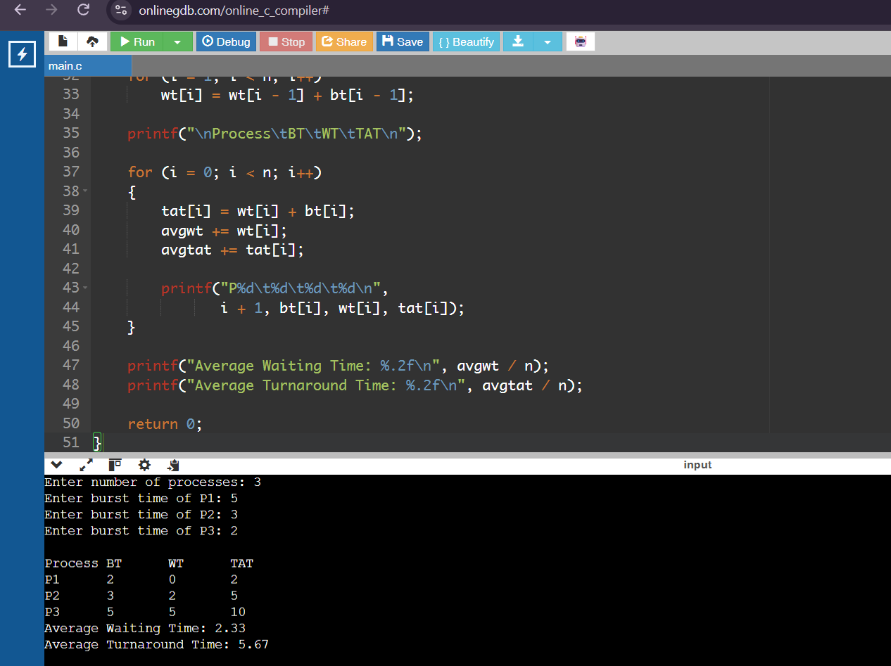

Process BT WT TAT
P1 2 0 2
P2 3 2 5
P3 5 5 10

Average Waiting Time: 2.33
Average Turnaround Time: 5.67

- DESIGN A CPU SCHEDULING PROGRAM WITH C USING PRIORITY SCHEDULING

Aim:
To write a C program that selects the waiting process with the highest priority for execution. Here, a smaller priority number means higher priority.
Program:
#include <stdio.h>
int main()
{
int n, i, j, bt[20], p[20], wt[20], tat[20];
int temp;
float avgwt = 0, avgtat = 0;
printf("Enter number of processes: ");
scanf("%d", &n);
for (i = 0; i < n; i++)
{
printf("Enter burst time of P%d: ", i + 1);
scanf("%d", &bt[i]);
printf("Enter priority of P%d: ", i + 1);
scanf("%d", &p[i]);
}
for (i = 0; i < n - 1; i++)
{
for (j = i + 1; j < n; j++)
{
if (p[i] > p[j])
{
temp = p[i];
p[i] = p[j];
p[j] = temp;
temp = bt[i];
bt[i] = bt[j];
bt[j] = temp;
}
}
}
wt[0] = 0;
for (i = 1; i < n; i++)
wt[i] = wt[i - 1] + bt[i - 1];
printf("\nProcess\tPriority\tBT\tWT\tTAT\n");
for (i = 0; i < n; i++)
{
tat[i] = wt[i] + bt[i];
avgwt += wt[i];
avgtat += tat[i];
printf("P%d\t%d\t\t%d\t%d\t%d\n",
i + 1, p[i], bt[i], wt[i], tat[i]);
}
printf("Average Waiting Time: %.2f\n", avgwt / n);
printf("Average Turnaround Time: %.2f\n", avgtat / n);
return 0;
}

Output:
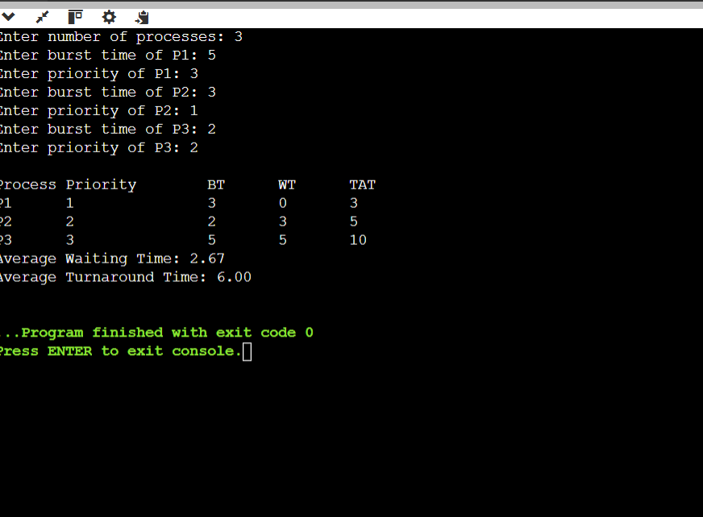
Process Priority BT WT TAT
P1 1 3 0 3
P2 2 2 3 5
P3 3 5 5 10

Average Waiting Time: 2.67
Average Turnaround Time: 6.00
- DESIGN A CPU SCHEDULING PROGRAM WITH C USING ROUND ROBIN SCHEDULING

Aim:
To write a C program to schedule processes using Round Robin scheduling with a fixed time quantum.
Program:
#include <stdio.h>
int main()
{
int n, i, tq, time = 0, done;
int bt[20], rem[20], wt[20], tat[20];
float avgwt = 0, avgtat = 0;
printf("Enter number of processes: ");
scanf("%d", &n);
for (i = 0; i < n; i++)
{
printf("Enter burst time of P%d: ", i + 1);
scanf("%d", &bt[i]);
rem[i] = bt[i];
}
printf("Enter time quantum: ");
scanf("%d", &tq);
if (tq <= 0)
{
printf("Time quantum must be positive.\n");
return 1;
}
do
{
done = 1;
for (i = 0; i < n; i++)
{
if (rem[i] > 0)
{
done = 0;
if (rem[i] > tq)
{
time += tq;
rem[i] -= tq;
}
else
{
time += rem[i];
wt[i] = time - bt[i];
rem[i] = 0;
}
}
}
} while (!done);
printf("\nProcess\tBT\tWT\tTAT\n");
for (i = 0; i < n; i++)
{
tat[i] = wt[i] + bt[i];
avgwt += wt[i];
avgtat += tat[i];
printf("P%d\t%d\t%d\t%d\n",
i + 1, bt[i], wt[i], tat[i]);
}
printf("Average Waiting Time: %.2f\n", avgwt / n);
printf("Average Turnaround Time: %.2f\n", avgtat / n);
return 0;
}

Output:
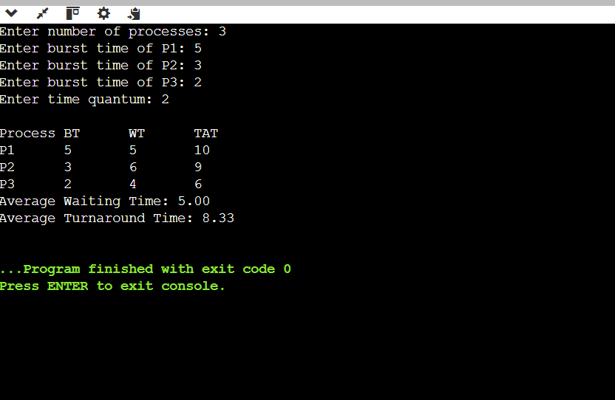
Process BT WT TAT
P1 5 5 10
P2 3 6 9
P3 2 4 6
Average Waiting Time: 5.00
Average Turnaround Time: 8.33

- Critical Section Problem using Peterson's Algorithm
Aim:
To implement a solution to the critical section problem using Peterson's Algorithm for two processes.
Program:
#include <stdio.h>
#include <pthread.h>
#include <stdbool.h>
bool flag[2] = {false, false};
int turn;
void *process(void *arg)
{
int i = *(int *)arg;
int j = 1 - i;
flag[i] = true;
turn = j;
while (flag[j] && turn == j)
;
printf("Process %d is in critical section\n", i);
flag[i] = false;
printf("Process %d is in remainder section\n", i);
return NULL;
}
int main()
{
pthread_t p1, p2;
int i = 0, j = 1;
pthread_create(&p1, NULL, process, &i);
pthread_create(&p2, NULL, process, &j);
pthread_join(p1, NULL);
pthread_join(p2, NULL);
return 0;
}

Output:
